Batch: A1 Roll No.: 16010123012
Experiment No.: 08
Grade: AA / AB / BB / BC / CC / CD /DD
Signature of the Staff In-charge with date

Title: Implement following Edge detection operators (Prewitt, Sobel, Robert, and Laplacian).
Objective: To learn and understand different edge detection operators.
Expected Outcome of Experiment:

CO | Outcome
CO4 | Design & implement algorithms for digital image enhancement, segmentation & restoration.
Books/ Journals/ Websites referred:
- http://www.mathworks.com/support/
- www.math.mtu.edu/~msgocken/intro/intro.html.

- R. C.Gonsales R.E.Woods, “Digital Image Processing”, Second edition, Pearson Education
- S.Jayaraman, S Esakkirajan, T Veerakumar “Digital Image Processing “Mc Graw Hill.
- S.Sridhar,”Digital Image processing”, oxford university press, 1st edition."
Pre Lab/ Prior Concepts:
Image segmentation can be achieved in two ways,

- Segmentation based on discontinuities of intensity.

- Segmentation based on similarities in intensity.

Edge information in an image is found by looking at the relationship a pixel has with its neighbourhoods. If a pixel’s gray-level value is similar to those around it, there is probably not an edge at that point. If a pixel has neighbors with widely varying gray levels, it may present an edge point.
Edge Detection Methods:
Many are implemented with convolution masks and based on discrete approximations to differential operators. Differential operations measure the rate of change in the image brightness function.Some operators return orientation information. Other only return information about the existence of an edge at each point.
Sobel Operator
The operator consists of a pair of 3×3 convolution kernels as shown in Figure 1. One kernel is simply the other rotated by 90°.
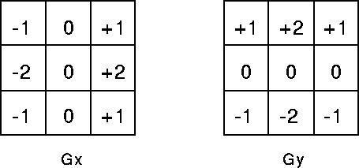

These kernels are designed to respond maximally to edges running vertically and horizontally relative to the pixel grid, one kernel for each of the two perpendicular orientations. The kernels can be applied separately to the input image, to produce separate measurements of the gradient component in each orientation (call these Gx and Gy). These can then be combined together to find the absolute magnitude of the gradient at each point and the orientation of that gradient. The gradient magnitude is given by:

Typically, an approximate magnitude is computed using:

which is much faster to compute. The angle of orientation of the edge (relative to the pixel grid) giving rise to the spatial gradient is given by:

Robert’s cross operator:

The Roberts Cross operator performs a simple, quick to compute, 2-D spatial gradient measurement on an image. Pixel values at each point in the output represent the estimated absolute magnitude of the spatial gradient of the input image at that point. The operator consists of a pair of 2×2 convolution kernels as shown in Figure. One kernel is simply the other rotated by 90°. This is very similar to the Sobel operator.

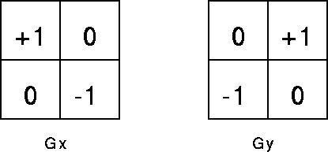

These kernels are designed to respond maximally to edges running at 45° to the pixel grid, one kernel for each of the two perpendicular orientations. The kernels can be applied separately to the input image, to produce separate measurements of the gradient component in each orientation (call these Gx and Gy). These can then be combined together to find the absolute magnitude of the gradient at each point and the orientation of that gradient. The gradient magnitude is given by:

An approximate magnitude is computed using:

Which is much faster to compute? The angle of orientation of the edge giving rise to the spatial gradient (relative to the pixel grid orientation) is given by:

Prewitt’s operator:

Prewitt operator is similar to the Sobel operator and is used for detecting vertical and horizontal edges in images.
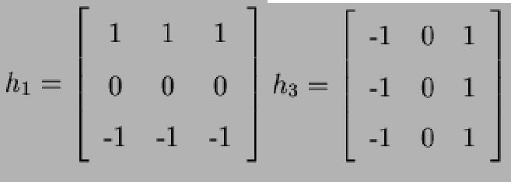

Laplacian of Gaussian:

The Laplacian is a 2-D isotropic measure of the 2nd spatial derivative of an image. The Laplacian of an image highlights regions of rapid intensity change and is therefore often used for edge detection. The Laplacian is often applied to an image that has first been smoothed with something approximating a Gaussian Smoothing filter in order to reduce its sensitivity to noise. The operator normally takes a single gray level image as input and produces another gray level image as output.
The Laplacian L(x,y) of an image with pixel intensity values I(x,y) is given by:
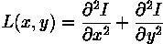

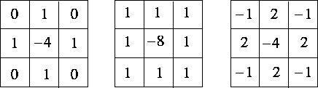
Since the input image is represented as a set of discrete pixels, we have to find a discrete convolution kernel that can approximate the second derivatives in the definition of the Laplacian. Three commonly used small kernels are shown in Fig below

Because these kernels are approximating a second derivative measurement on the image, they are very sensitive to noise. To counter this, the image is often Gaussian Smoothed before applying the Laplacian filter. This pre-processing step reduces the high frequency noise components prior to the differentiation step.
Implementation Details:
clc;
clear;
close all;

img = imread('image.jpg');

if size(img,3) == 3
gray = rgb2gray(img);
else
gray = img;
end

gray = double(gray);
figure;
imshow(uint8(gray));
title('Original Grayscale Image');
sobel_x = [-1 0 1; -2 0 2; -1 0 1];
sobel_y = [-1 -2 -1; 0 0 0; 1 2 1];

gx = conv2(gray, sobel_x, 'same');
gy = conv2(gray, sobel_y, 'same');
sobel = sqrt(gx.^2 + gy.^2);
figure;
imshow(mat2gray(sobel));
title('Sobel Edge (Mask)');
prewitt_x = [-1 0 1; -1 0 1; -1 0 1];
prewitt_y = [-1 -1 -1; 0 0 0; 1 1 1];

gx = conv2(gray, prewitt_x, 'same');
gy = conv2(gray, prewitt_y, 'same');
prewitt = sqrt(gx.^2 + gy.^2);
figure;
imshow(mat2gray(prewitt));
title('Prewitt Edge (Mask)');

roberts_x = [1 0; 0 -1];
roberts_y = [0 1; -1 0];

gx = conv2(gray, roberts_x, 'same');
gy = conv2(gray, roberts_y, 'same');
roberts = sqrt(gx.^2 + gy.^2);
figure;
imshow(mat2gray(roberts));
title('Roberts Edge (Mask)');
laplacian_mask = [0 -1 0; -1 4 -1; 0 -1 0];

laplacian = conv2(gray, laplacian_mask, 'same');

figure;
imshow(mat2gray(laplacian));
title('Laplacian Edge (Mask)');
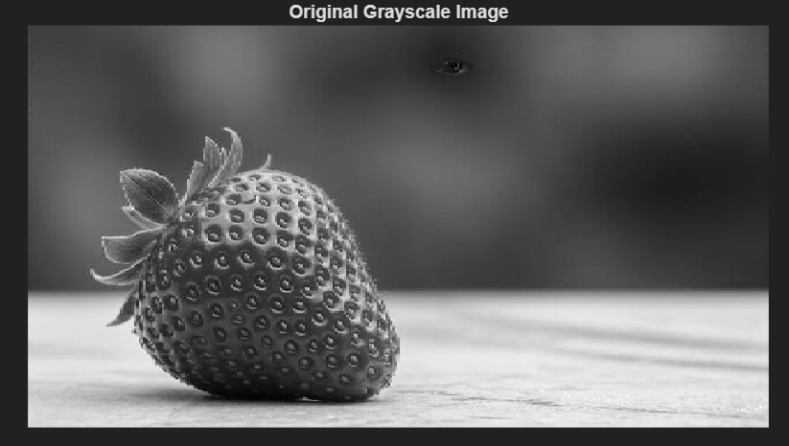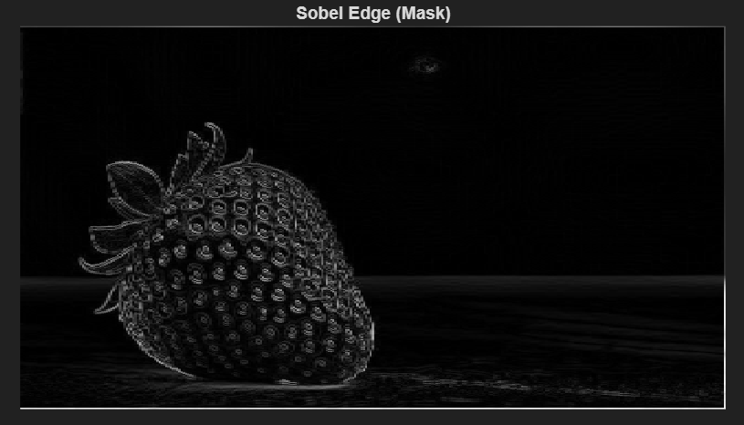
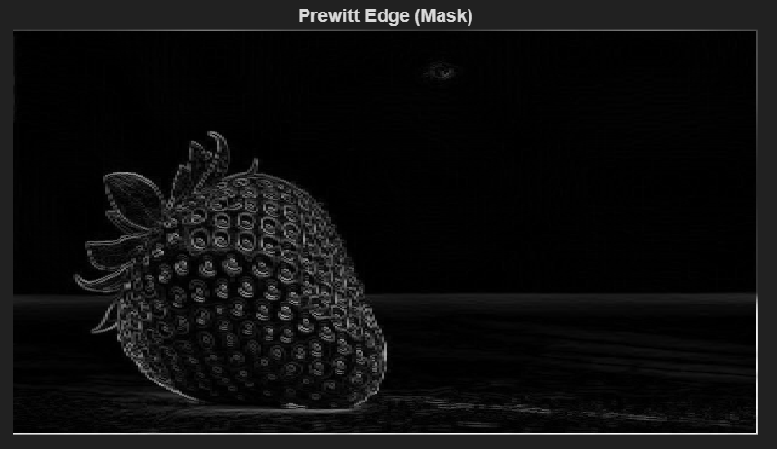
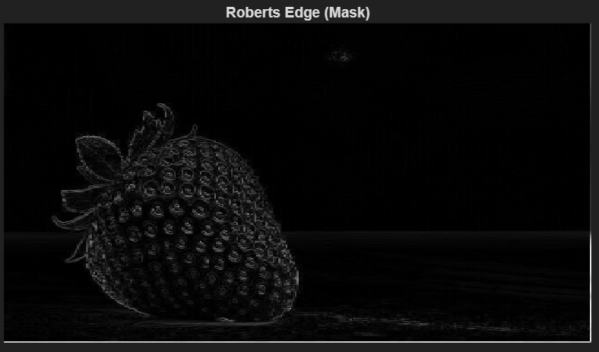
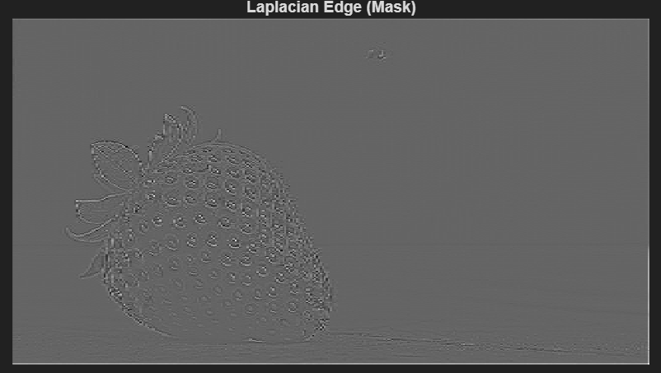
Write Algorithm and Matlab commands used:
Algorithm:
Start the program.
Read the input image (image.jpg).
Convert the image to grayscale if it is a color image.
Convert the image into double format for computation.
Define convolution masks for:
- Sobel operator (Gx, Gy)
- Prewitt operator (Gx, Gy)
- Roberts operator (Gx, Gy)
- Laplacian operator
Apply convolution using each mask on the grayscale image.
Compute gradient magnitude for Sobel, Prewitt, and Roberts operators.
Normalize the output images for proper display.
Display:
- Original grayscale image
- Sobel edge image
- Prewitt edge image
- Roberts edge image
- Laplacian edge image
Stop the program.
Matlab Commands:
imread() – Reads the input image
rgb2gray() – Converts RGB image to grayscale
double() – Converts image to double precision
conv2() – Performs 2D convolution using masks
sqrt() – Computes gradient magnitude
figure – Opens a new figure window
imshow() – Displays image
mat2gray() – Normalizes image for display
title() – Adds title to image
Conclusion:
In this experiment, I implemented various edge detection operators including Sobel, Prewitt, Roberts, and Laplacian using MATLAB. I observed that gradient-based operators such as Sobel and Prewitt detect edges in specific directions, while Roberts detects diagonal edges. The Laplacian operator highlighted regions of rapid intensity change but was more sensitive to noise.
Date: 04 / 04 / 26 Signature of faculty in-charge
Post Lab Descriptive Questions
- Explain the need of a LOG operator.
The Laplacian operator is highly sensitive to noise because it uses second-order derivatives. To reduce this sensitivity, the image is first smoothed using a Gaussian filter and then the Laplacian is applied. This combination is called the Laplacian of Gaussian (LOG) operator. Need:
Reduces noise before edge detection
Detects edges more accurately
Combines smoothing + edge detection in one process
Highlights zero-crossings which indicate edges

- Explain the technique of thresholding for segmentation.
Thresholding is a technique used to separate objects from the background based on pixel intensity.
If pixel intensity ≥ T → object (white)
If pixel intensity < T → background (black)
Types:
Global thresholding → single threshold for entire image
Local/adaptive thresholding → threshold varies across image
Use:
Image segmentation
Object detection
Binary image creation

